Great food, good German beer (but Belgium beer is better…), and of course the most important fact; magnificent organs with great organists! It was also an opportunity to see the Stalinistic architecture of the former East-Germany, thanks to some drivers we could see the architecture VERY close, but the people stayed very friendly. But let me tell you a little bit more about the great sounds we’ve heard.
The trip started on the evening of Thursday 11 November, we gathered in the Novotel to have a meal and a drink…of course. Here we met each other and we talked about the organs we were going to visit. Every visit was preceded with an introduction and a discussion at the end.
The next day, early in the morning, we were going to visit the first organ. Actually the most of us weren’t prepared on what we were going to hear there. It was the organ from Pomssen, made by Gottfried Richter in 1671. The sound was unbelievable, it was bright, intense, and very rich! It had a meantone tuning and a short octave. The principal 4 was fresh and direct. The Grossgedackt 8 had a beautiful intonation with a nice “spuk”. The Trompeten 8 was dark and “buttery”. The Posaunen 16 was raw and round. The mixture mixed itself very good with the other stops and gave some more brilliance to it. Like it should be. Everybody was very impressed by this instrument.
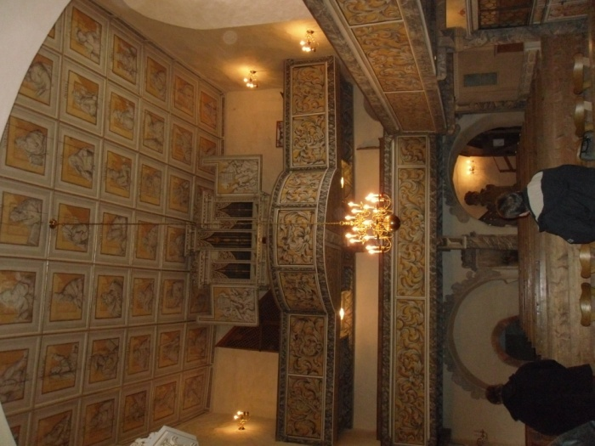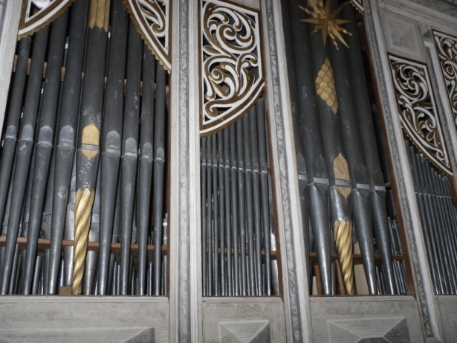
After this instrument it was time for a break…and it was necessary. After the break we went to Rötha, here we were going to visit two organs of Silbermann. The two organs were in the Georgenkirche (1721) and in the Marienkirche (1722). These were also very fine instruments. The sound was also very nice but they had a very strong intonation, they were a bit straight intonated. For some of us the intonation was to strong, some were even a bit disappointed.
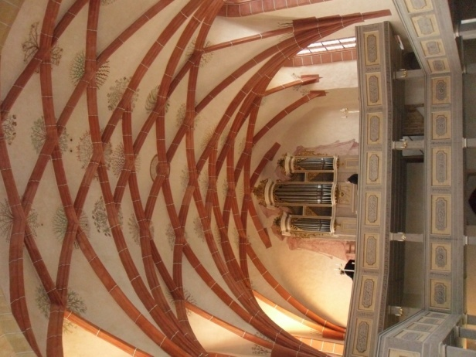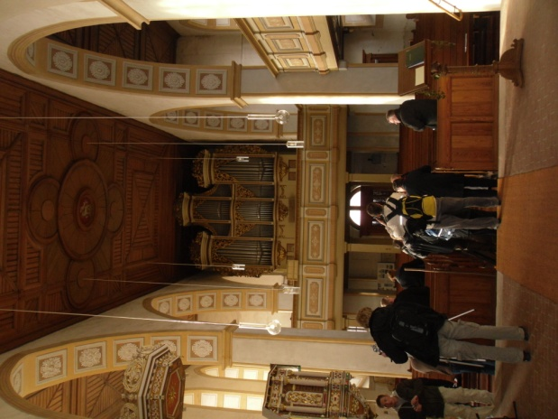
After this we had some discussions and went to a bakery to eat something near the Michaeliskirche. After this we went to the church and we’ve seen a Sauer organ. This was again a completely other concept. It was a very strange atmosphere, it was already dark outside, and there was not so much light in the church. The architectural concept was in the jugendtil-style, the organ was beautifully processed in the church. The front of the organ was a bit “tree-like” with roots and tree-tames. The sound of the organ was warm and a bit mellow, it was perfectly for playing the Romantic repertoire (like Reger). One of the first things I immediately noticed was that the playing table remained me very much at the organs of Walcker. With the colors and typical stops and layout. I was quite impressed by the whole concept of this visit.
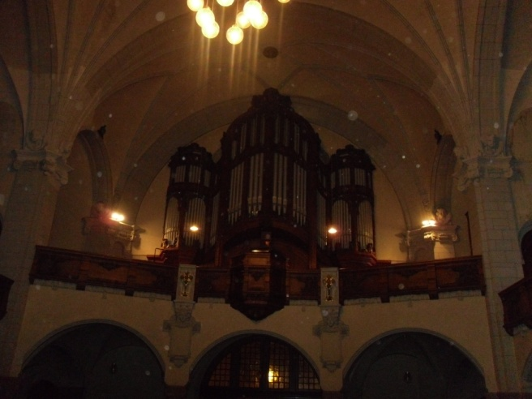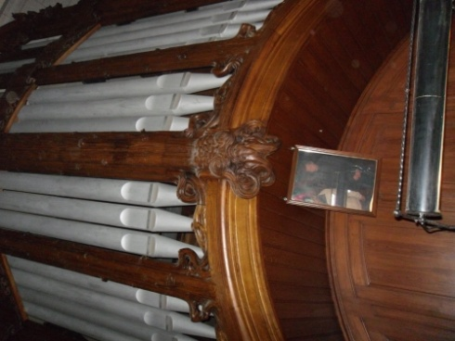
After this we went back to the hotel and we were going to have supper in a very cozy restaurant.
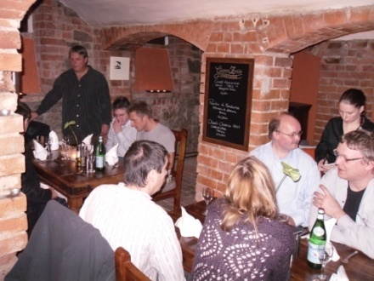
The next day we went to Hohenmölsen, to visit an early Ladegast organ from 1851. This was also a very beautiful instrument, many of us agreed with that. Friedrich Ladegast worked in a lot of workshops before he began on his own. He worked also with Aristide Cavaillé-Coll and he used the different techniques he learned with C.C. in his own instruments later on. He had also a strong preference for the organs of Silbermann and he liked the mechanical organs very much. Many organ builders would follow his concept of building later on.
When I went inside the organ, it was astonishing how detailed the windchest was made. And again I noticed the influence of Silbermann, the very wide intonation of the mouth, for example those of the front pipes. The wind pressure is very low but the organ’s sound is still powerful. When we sang together with the organ we noticed that the organ mixes wonderfully with human voices. And of course that is the purpose of such an organ, it is meant to do that for the liturgical masses. Very nice!
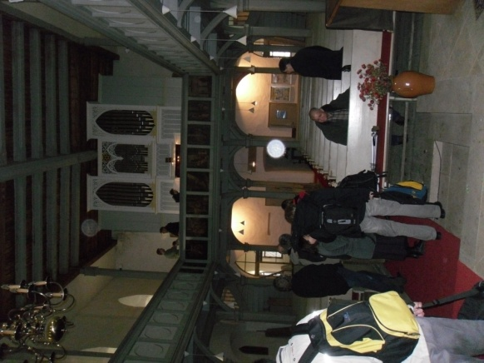
After visiting this organ we went to the Gemeindehaus to have some cake with coffee. We were welcomed very friendly there and the foods and drinks were very good. And of course we discussed the organ we had seen.

When we finished visiting this place we went further on to Naumburg, to see the Hildebrandt from 1748 in the Wenzelskirche. The first impression was very imposing, the case was very big and beautiful. We were guided by Jan Werner, an organrestorer from Eule. He guided us inside the organ and showed us some very interesting things and details. Also he explained a lot about the sound-idea, because it is actually more a reconstruction than a restoration, and therefore it stays an idea how the original would have sound. They made the reconstruction from the original still existing pipes in the organ and restored the original pipes very carefully. I was astonished how detailed and careful they made the restoration of the pipes! It is an example for us all. The point was to obtain as much as possible from original pipe-material. Based on the scales they then had, they reconstructed the rest of the organs pipes. But of course they had the time for the restoration, it lasted 7 years.
Then it was time for a drink and a meal, we went to a nice Italian restaurant in the neighborhood together with Jan Werner.
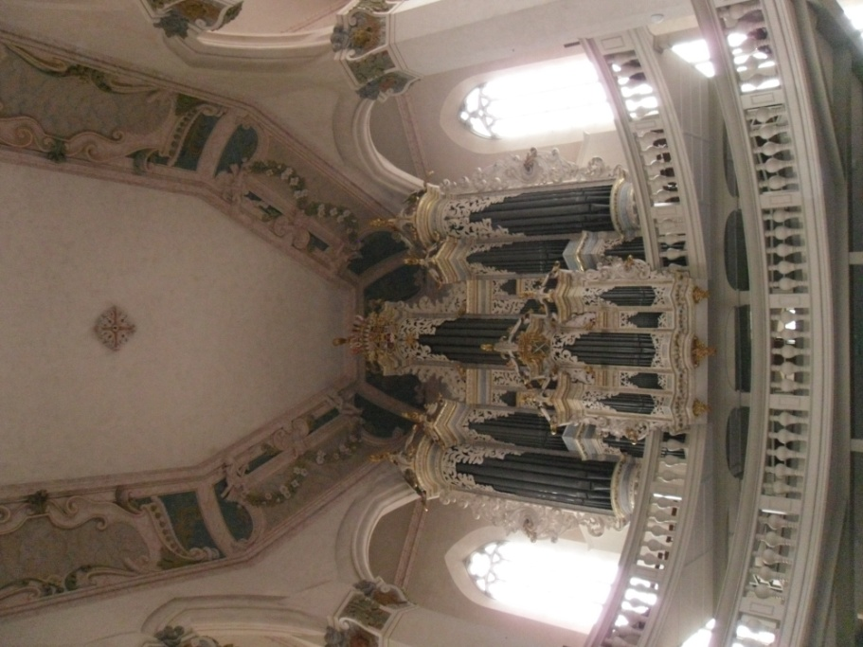
The following organ was in Merseburg. There we met Michael Schönheit and Denny Wilke, they explained a lot about the organ we were seeing there. It was an organ from Hildebrandt but with some modern modifications. Actually it wasn’t so much Hildebrandt anymore… . Michael Schönheit and Denny Wilke played some French romantic music on it and demonstrated the quality’s of the organ. The case was one of the most impressing we had seen in our days we were in the region of Leipzig!
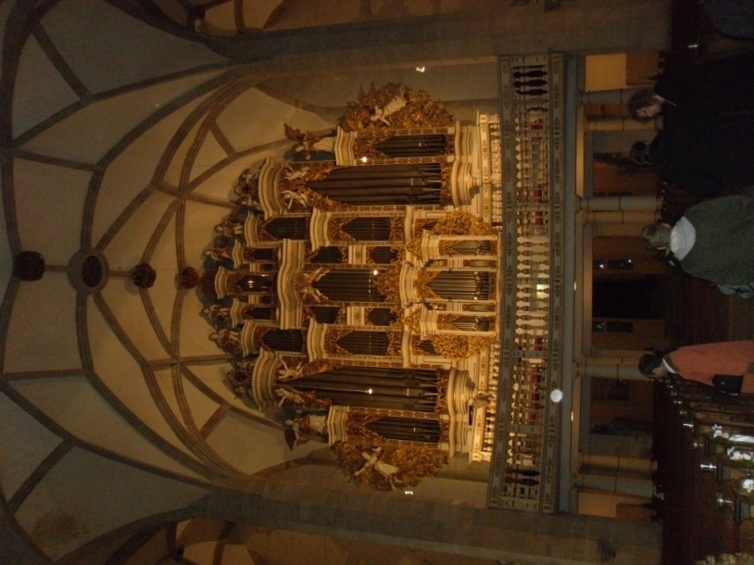
When we grew tired of all the talking and discussing after the concert on the organ, we went to a nice and cozy restaurant in Merseburg. There we talked about the instruments we had seen. Afterward we went back to the hotel to have a well earned nap.

The following day, after the breakfast, we went to the mass in the Bach-churches, more specific the St-Nikolai, there stood and organ from Eule. Also there was singing a very nice boys choir. Only imagining Bach had played there… .
After the mass we went to the instrumental museum of Leipzig. Also one of the things I loved to see. You see, not only I built organs but also harpsichord and clavichords. So it was a very good opportunity to see these instruments. And we loved it all! There stood a very nice Silbermann organ in the concert room in het museum. When there was a demonstration of the instrument, I walked around to hear the sound of it. And on a specific moment I stopped because I thought I heard a woman singing, but nobody was singing, it was the organ, a very strange but beautiful experience.
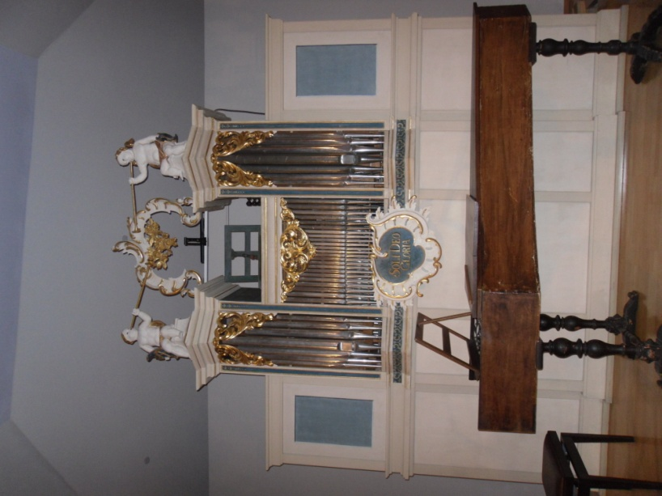
After that organ we went further on the Kinoo-organ. This was a very strange but thought-opening experience. All those bells and machines in the organ, the wound was unbelievable. It was really and orchestra and it sounded exactly like that! It is also an organ which asks a lot of maintenance. Very nice and worth the visiting, if you are searching for new ideas in your organ! The organ was well restored by Jehmlich orgelbau.
Then it was time to have a meal for a very small amount of money in the museum itself. And it was very good! If you go to Leipzig visit the museum AND it’s restaurant! You won’t regret! After the meal it was time to leave, I had still 6 hours to drive. Everybody said his farewells and alas it was the end of a beautiful trip.
This trip we thank especially to Kristian Wegscheider, it was very good planned and had some very nice locations to eat and drink. Thank you Kristian in name of us all! And also I would like to thank the organists like Michael Schönheit and Denny Wilke, who played for us. But especially Martin Rost, he made the instruments he played for us sound so “right”, and he switched from instrument to instrument like it was nothing, and every time he succeeded in playing the organ masterly like it was an old friend. Thank you all for the nice trip!

