Mysterie, beauty and splendour, the harpsichords of Vincent Tiabut
When I went on one day to the MIM in Brussels, I was fascinated by the many beautiful instruments. But one instrument took completely my attention. It was an exceptional instrument which was streamlined like an Italian, unbelievable decorated like a Frenchman from the court of Louis XIV and proud and impressive like a German. It was an international instrument, you could feel it. There was an atmosphere of mystery around the instrument, everyone who passed couldn’t just walk around it, they HAD to look at it. It was beautiful. Such beauty caught in one instrument, I almost hadn’t seen it somewhere else in my young career. It was the harpsichord of Vincent Tibaut, dating 1679.
When I started my fourth year at the royal conservatory Gent (Belgium), I had to chose a theme for my investigation. It was an obvious choice of course: Vincent Tibaut! With this opportunity it was an ideal situation for me to examine all the instruments of this builder. An great experience!

Who was Vincent Tibaut?
This is a short summary of who Vincent Tibaut actually was.
Tibaut is born in Coyron in Bretagne (natif de Coyron en Brethanie). I have filtered some of the most important descriptions in the archives of Toulouse. Here I can find that:
“Vincent Tibaut, compaignon Menuisier” has got an audition for the craft by Lafolie, the syndicate of the city and through Poitevin, attorney of the King. In this statement he had to ´payer les droits de la ville, hospital et confrairie auxquelles fins ledit Thibaut a presté le sermant en tel cas requis et acostumé.´
Here we can see that i twas not so simple for someone to become an independent builder/joiner (en that’s also the fact for other businesses). You had to be accepted by the city and pay several taxes for the city, hospital, etc., before you could join the Guild.
Then the most interesting feature comes, Vincent Tibaut was a member of the Guild of Toulouse and he paid also taxes for this. He had to sworn an oath and had to make sure he would assist the Guild with meetings, etc. . The Guild was of the same caliber than that of Antwerp; Guild of St-Luce (where the Ruckers where members).
In the papers of Tibaut his wedding vow, we can see that he was staying in Saint-Carbes, in a small parish of this, named Saint-Etienne. We can also deduct that he was a master joiner? His parents are also named. His father was a master carpenter of Nantes, named Jean Tibaut. His mother was Jacquotte Aspot.
What is most interesting is that Vincent didn’t had to make a masterpiece before entering the Guild. This is due to the fact that is father was a master carpenter and Vincent was his apprentice. This was clearly a common way in the Ancien Regime.
Together with his wife he’s getting five children, but none of them survives.

Research and comparison
The investigation started with the harpsichord of the Musée de la musique Paris. Here there was one on the remaining instruments by Tibaut, dated 1691. The second instrument which I have examined, was in a private collection in Bretagne, dating 1681, this is the only playable instrument of the three. The third instrument is located in Brussels, in the MIM, and is dated 1679.
From these three instruments which I have examined thorough, I have made a study of comparison and collected all information which wasn’t much. I studied the information and came to the conclusion that many crucial parts of information where missing, and the information that was existing, was sometimes wrong. Here is an example: pear wood that was tangled with elder wood. Also faults in technical drafts are always the fact.
My idea is that you use a draft as a guidance, but never as a single source of information. Also the fact that they used to work completely different in ancient times (15-16-17-18th century) has one to remember. They worked proportional, this means that they worked with proportions like circulars etc., where they took multiples of. But this fact would lead is too far away from the point of discussion.
With these facts in mind, I began my investigation and tried to make a “as complete possible work” of Vincent Tibaut. I also note that this is just a small part of what I have written. When the research ends, my complete work will be available with lots of photographs of the instruments.
Comparison of the instruments

Paris
This instrument is in his original state, as far as we can look of course. The instrument is heavily damaged with makes it very interesting, in this way, I could look in places where it would be otherwise impossible. There are much Italian influences visible on the instrument. This was not such a big surprise because the 17th century keyboard instruments where almost all under influence of Italy. A few of the Italian characteristics:
- The corpus is globally 7-9mm thick
- The inner construction exists of knees and a lot of nails
- The soundboardbridges are lightly profiled
On the photographs of the inside of the instrument, you can see one of the ribs. The most interesting feature of this, is that the 4-foot hitch pin rail is glued to this rib. Pay attention to the measurements of the 4-foot hitch pin rail, it’s 10-12 mm caré.
The keyboard has two blocks with a scroll, but originally there were one on each end of the keyboards (four on total thus). This is a German characteristic.

brussels
This instrument is heavily restored in the 60’. This doesn’t predict many good. As the first point, the painting on the soundboard are not original. These are from a later date then the instrument. Also I have many suspicions that the intarsia of the lid is also not a part of the original instrument. Most probably it is added when the buyer had the instrument and wanted to add his scutcheon on the instrument.
The construction doesn’t differ very much from the instrument of Paris, the only point of much difference is that this instrument is more decorated. The front of the keys are cut in the same way and the keyboard blocs have the shape of lions. The legs are all made in the same way, four are left turning, the other four are right turning. Probably the only real original intarsia is the small band with palm motives on the edges of the sides and lid. This type of decoration for furniture, was typical for the region of Toulouse in the 17th century. I think in this way that someone else did the decoration, someone who was specialized in intarsia of Toulouse.
The sharps are made of solid bone, sometimes I’ve found that the sharps are made of two pieces which are limed together. The height of the sharps is: 10mm to 8mm. I have also found leather plectra in the instrument but that is 100% not original.

French private collection
This is most interesting because it’s still playable. And there are several recordings of this instrument. This instrument go’s further in the line of the other instruments, with the same decoration (except the intarsia from that of Brussels).
The paintings on the soundboard look original but I am quite sure that they aren’t. Because they are to romantic. The material which the rosette is made off, is difficult to analyze. For this moment I suspect that it is made of lead. But wood is also possible. I am still searching for this.

Replica
I’ve made a copy as close as possible. The sides of the instrument are mitered together without a dove tail or sort like connections. I used sometimes little plugs to connect them (which I’ve also found in the originals). The keyboard has a compass of GG-c3 (with short octave) and it’s made of popular. I’ve found different types of material for the jacks. But with a more detailed observation, the most probably material that is original, would be Sorbus domestica. I’ve made the rosette of lead and added gold leaf on it.
The global lengths of the instruments are 2070mm till 2100mm. The widths are 760mm to 761mm. the height is 226mm to 232mm. the distances of the snares is given in this table.
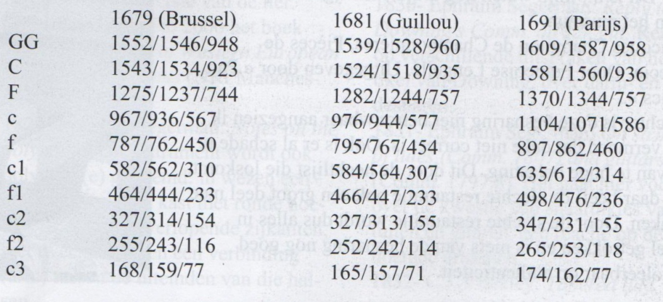

Photographs (you can place these where you want them in the article):
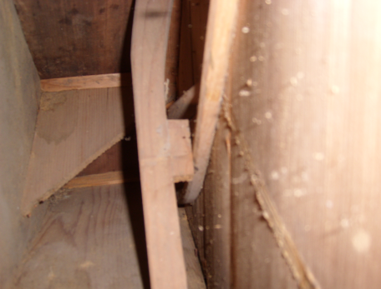
Inside of the instrument
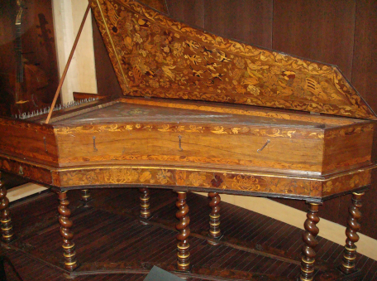
Tibaut of Brussels
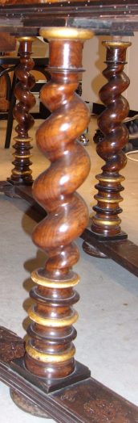
Legs of Tibaut Brussels
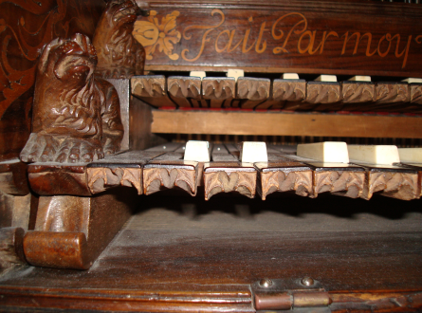
Keyboard Tibaut Brussels
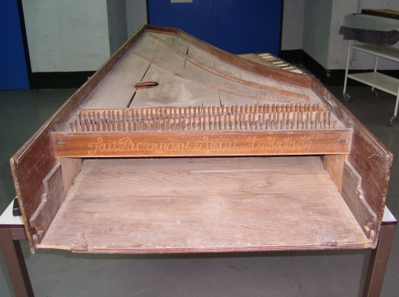
Tibaut Paris
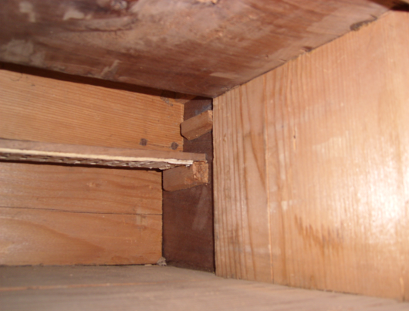
Tibaut paris, where keyboard is placed
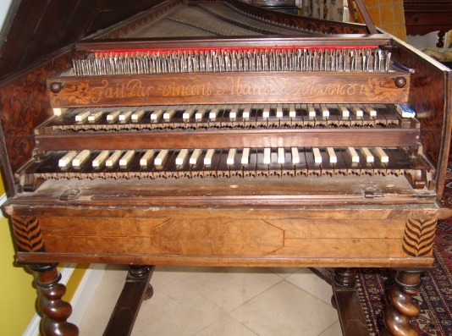
Tibaut private collection
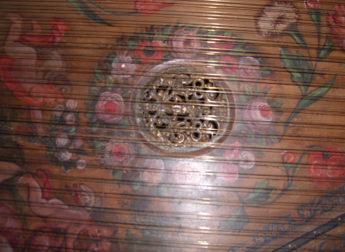
Tibaut private collection

Musical instruments museum in Brussels
Direction: historical keyboard building
For my final exam
Museum of musical instruments,Brussels
For exempel: Jacques Champion de Chambonnières, pièces de clavecin. By Françoise Lengellé. Produced by Pan Classics.

